**Question 1:** Every Output shown below is from the python **Assignment1_Question1.py**

**PART A.**

* Following are the results from the output of python code:

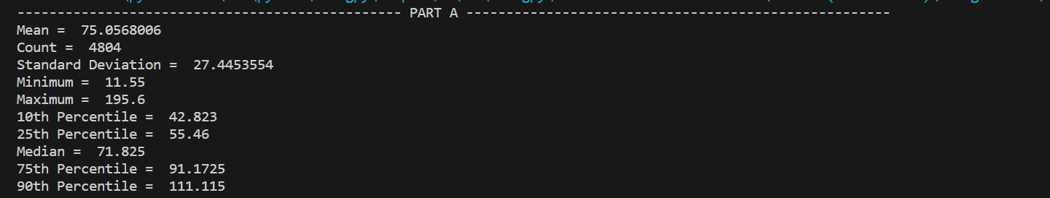

**PART B.**

As given in question we need to recommend a bin width having bins within range of 5 to 50. Considering this requirement, we can calculate the number of bins for every bin width given as follows:

* Number of bins = Round (Number of Maximum Value of Dataset / Bin Width)

Using this formula, we get following result:

|  |  |  |
| --- | --- | --- |
| D=Bin Width | Total Bins | Bins within 5-50 range |
| 0.1 | 1966 | N |
| 0.2 | 978 | N |
| 0.25 | 782 | N |
| 0.5 | 391 | N |
| 1 | 195 | N |
| 2 | 98 | N |
| 2.5 | 78 | N |
| 5 | 38 | Y |
| 10 | 19 | Y |
| 20 | 10 | Y |
| 25 | 8 | Y |
| 50 | 4 | N |
| 100 | 2 | N |

As given in the above table out of 13 bin widths only 4 widths fall under the required bin number condition.

* Now Using Shimazaki and Shinomoto method we can recommend the optimal bin width. In order to do so we need to calculate:

1. Calculate the number of observations falling under each bin.
2. Calculate the mean and variance.
3. Compute the Criterion C(d) = (2*mean - variance)/d*d, where d is the bin width.
4. The minimum value for C(d) from each d will be the optimal Bin Width

* Following is an example for the above method:

Take Bin Width, d = 5.

1. List of Observation for each bin: [4, 6, 42, 62, 94, 149, 222, 273, 323, 393, 368, 342, 342, 332, 327, 265, 219, 178, 181, 164, 126, 87, 53, 61, 48, 37, 29, 22, 16, 10, 9, 3, 6, 2, 4, 2, 2, 1]
2. Mean = 126.42105263157895

Variance = 16933.612188365652

1. C(d) = -667.2308033240998

* Below is the Screenshot of output for the same for every possible Bin width:

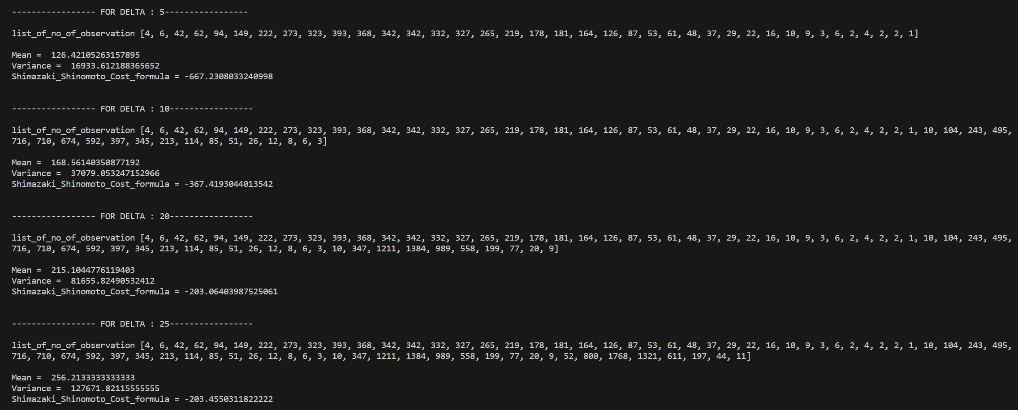

* By this calculation we get:

|  |  |  |
| --- | --- | --- |
| **D = Bin Width** | **Total Bins** | **C(d)** |
| 5 | 38 | -667.2308033 |
| 10 | 19 | -367.4193044 |
| 20 | 10 | -203.0640399 |
| 25 | 8 | -203.4550312 |

* From above calculation, the minimum value for criterion is for D = 5. Hence, we can say that 5 is the Optimal Bin Width.

The whole calculation is done in **Assignment1_Question1.py.**

**PART C.**

To draw the Density Estimator, we need to do following calculation:

1. Select a bin width h.
2. Calculate the midpoint of every bin.
3. For every midpoint **Mj** calculate -> **u = Xi – Mj/h**, where **Xi** is all the observation in the data
4. Based on u, we calculate the weight w(u) as:

* 1, if -0.5 < u <= 0.5
* 0, otherwise

1. Compute Density of midpoint 𝑝 ̂(u) = Σ w(u) / (Nh) , where N is the number of total observation.

As given, we will take Bin Width h = 5 which was compute from Part B.

As per the algorithm:

1. Bin Width h = 5
2. Midpoint list = [2.5, 7.5, 12.5, 17.5, 22.5, 27.5, 32.5, 37.5, 42.5, 47.5, 52.5, 57.5, 62.5, 67.5, 72.5, 77.5, 82.5, 87.5, 92.5, 97.5, 102.5, 107.5, 112.5, 117.5, 122.5, 127.5, 132.5, 137.5, 142.5, 147.5, 152.5, 157.5, 162.5, 167.5, 172.5, 177.5, 182.5, 187.5, 192.5, 197.5]
3. After Calculation we the list of Density of every midpoint as shown in below Screenshot:



After Calculating we can visualize this on graph as:

